
MEETING SCHEDULER WITH CONFLICT DETECTION SYSTEM

CMPS-347 Project

Submitted to:
Dr. Mostapha Chehaitly

Submitted by:
-Malak Al Haj - 202502240
-Rayan Maiz Mais - 2020503869

Table of Contents
1. Project Overview 2
1.1 Introduction 2
1.2 Problem Statement 3
1.3 Purpose of the system 4
2. Data Structure Used 5
2.1 Linked List 5
2.1 HashMap 6
2.3 ArrayList 7
3. UML Diagram 9
4. Classes 10
4.1 Main 10
4.2 Meeting Class 11
4.3 Employee Class 11
4.4 Room Class 12
4.5 MeetingNode Class 13
4.6 MeetingList Class 13
4.7 DailySchedule Class 14
4.8 MonthlyCalendar Class 15
4.9 MeetingScheduler Class 15
4.10 Validator Class 17
5. System Testing 18
5.1 Add Meeting 18
5.2 Search by Employee 20
5.3 Search by Room 21
5.4 Show All Meetings 21
5.5 Delete Meeting 21
5.6 Show Monthly Calendar 22
5.7 Exit 22
6. Code 23
7.Coclusion 30

1. Project Overview

1.1 Introduction
The Meeting Scheduler System is designed to help organizations manage and organize their meetings in a simple and efficient way. It allows users to create, view, and track meetings while ensuring that schedules remain clear, organized, and free of conflicts. The system provides an easy-to-use interface where users can enter meeting information such as dates, times, employees, and rooms, and the scheduler automatically checks for availability to prevent overlapping meetings.
In addition to organizing daily activities, the system also offers a calendar view that displays all schedules meetings in a clear, structured format. This helps users quickly understand upcoming events and stay updated on their responsibilities. Through its combination of scheduling, conflict detection, and easy navigation, the Meeting Scheduler System improves organization, reduces confusion, and supports smoother communication within the workplace.

1.2 Problem Statement
Many Workplaces have difficulty organizing meetings in an easy and clear way. Without a proper system, people may book the same room at the same time, or employees may accidentally schedule two meetings at once. It also becomes hard to view all meetings for the month in one place, which leads to confusion and disorganized planning.

1.3 Purpose of the system
- To help users schedule meetings easily and correctly.
- To avoid conflicts in rooms and employee schedule.
- To keep all meetings information in one place.
- To make it simple to see daily and monthly schedules.
- To improve organization and communication in the workplace.

2. Data Structure Used

2.1 Linked List
We used a linked list to store all the meetings in order. Each meeting is connected to the next one. This makes it easy to add or remove meetings without moving other meetings in memory.

Why Linked Lists?
- Meetings are constantly added and deleted. Linked lists allow easy insertion and deletion without shifting other elements.

- They maintain the order of meetings, which is important for showing schedules in chronological order.

- Each meeting points to the next meetings, which makes it simple to traverse and print all meetings.

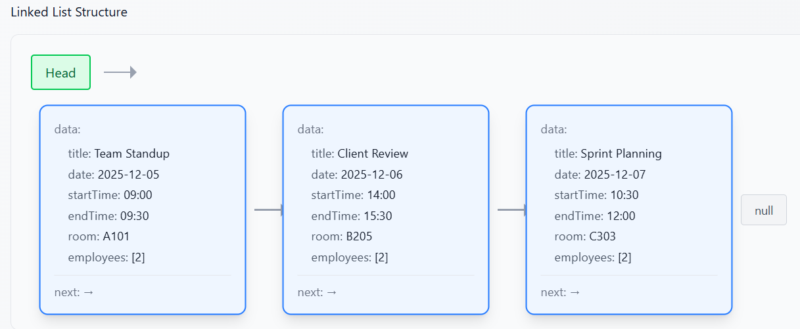

2.2 HashMap
HashMaps are used to quickly find meetings by room or by employee. The room or employee name is the key, and the list of meetings is the value. This allows the system to check for conflicts very fast.

Why HashMap?
- Searching in HashMap is very fast (almost instant).

- Each key can have multiple meetings as values.

- It helps detect conflicts efficiently without checking every meeting.

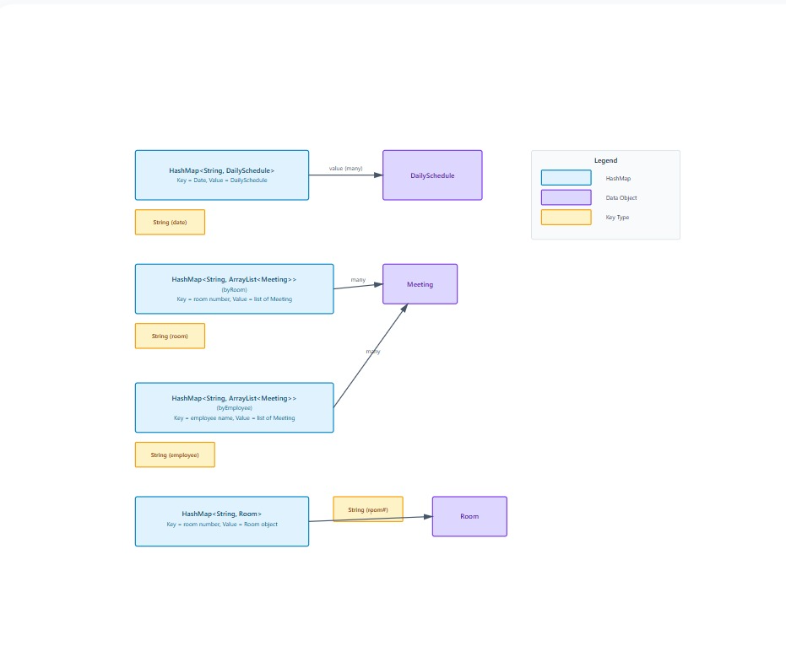

2.3 ArrayList
ArrayLists are used to store fixed dynamic data, like the list of employees attending a meeting or the list rooms. ArrayLists can grow or shrink easily when we add remove items.

Why ArrayList?
- Adding or removing items is simple and does not require complicated steps.
- Perfect for storing things like employees in a meeting or daily schedules.
- Easy to access each item by its position in the list.

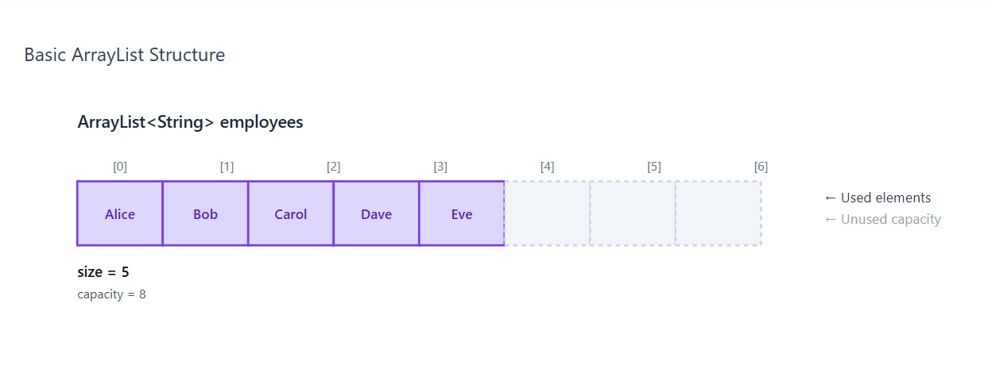

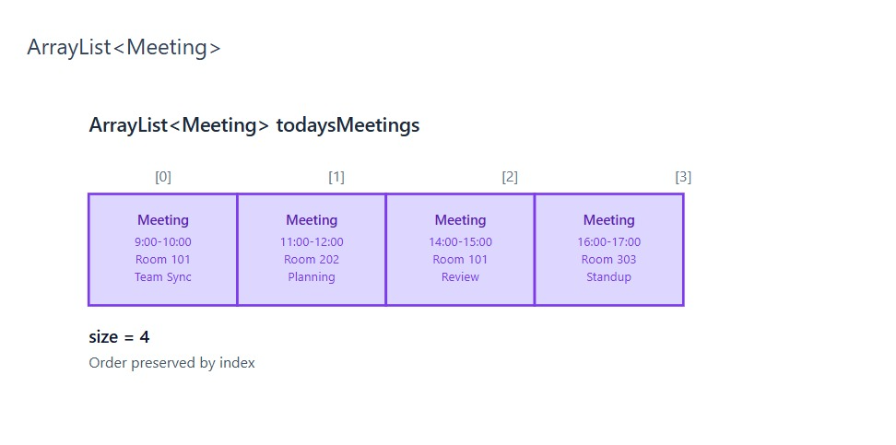
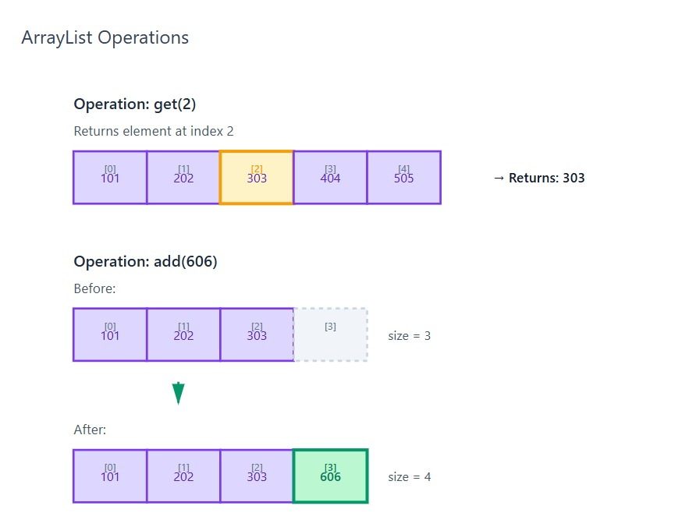

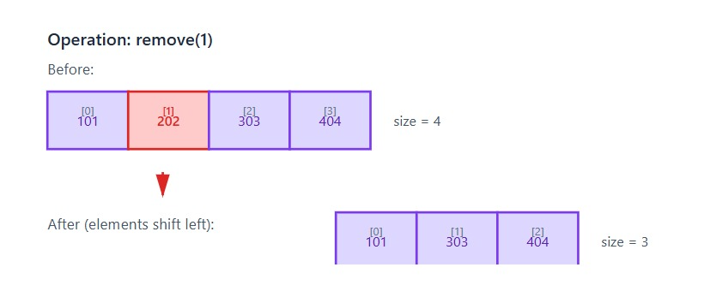

3. UML Diagram
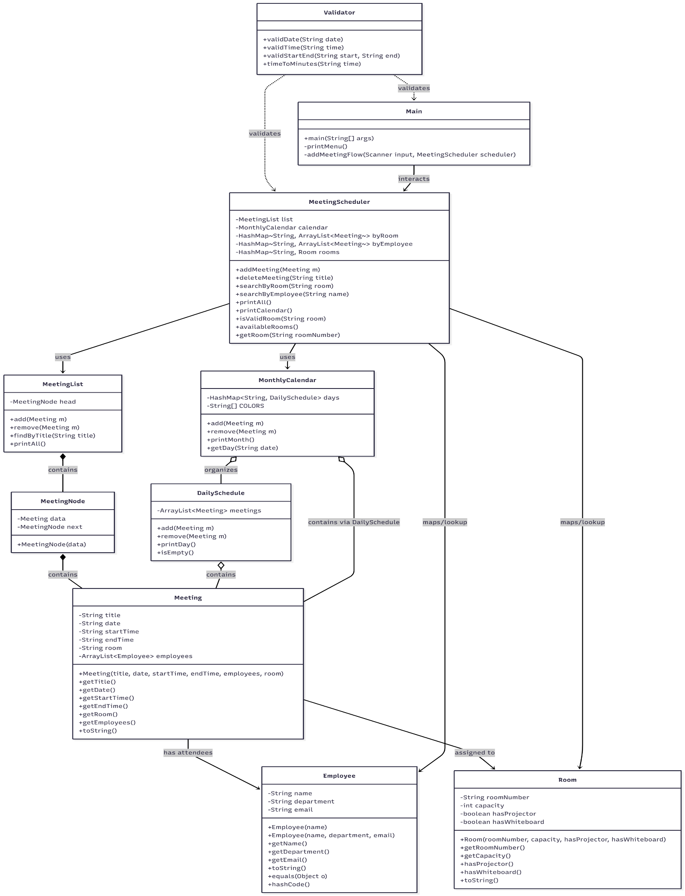

4. Classes

4.1 Main
The Main class is the starting point of the whole program. It shows the main menu and allows the user to choose what they want to do.
This class controls all the operations of the Meeting Scheduling System. From adding a new meetings, deleting a meeting, searching for meetings, viewing the calendar, and checking available rooms, everything begins from the main menu.
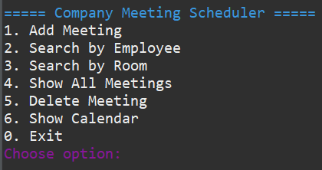
Description:
The Main class works closely with the MeetingScheduler, and it uses different data structures such as LinkedLists, HashMaps, and ArrayLists to handle meetings, employees, and rooms.
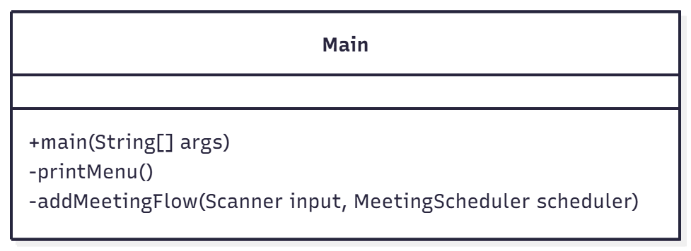

Main Operations and Time Complexity:
- Main(String[] args): Starts the program
Time Complexity: O(1)

- printMenu(): Displays menu options
Time Complexity: O(1)

- addMeetingFlow( Scanner input, MeetingScheduler scheduler): Reads input and adds a meeting.
Time Complexity: O(n + e)

4.2 Meeting Class
Description: The Meeting class represents a single meeting. It stores the meeting’s title, date, start and end times, room number, and the list of employees attending.
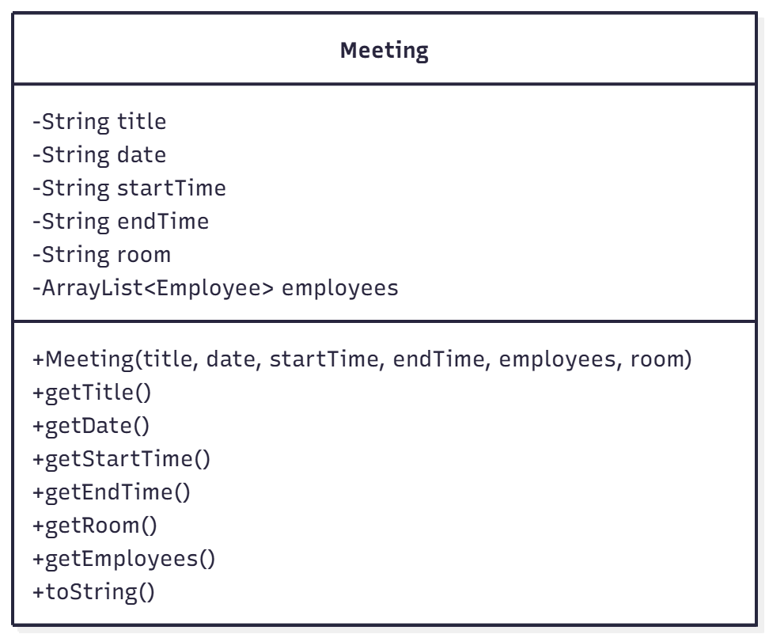
Methods and Time Complexity:
- getTitle(), getDate, getStartTime(), getEndTime(), getRoom(), getEmployees(): These are simple methods to get information about the meeting
Time Complexity: O(1)

- toString(): Converts the meeting details into a readable sting with all the employees.
Time Complexity: O(n)

4.3 Employee Class
Description: The Employee class represents a person who attend meetings. It stores their names department, and email.
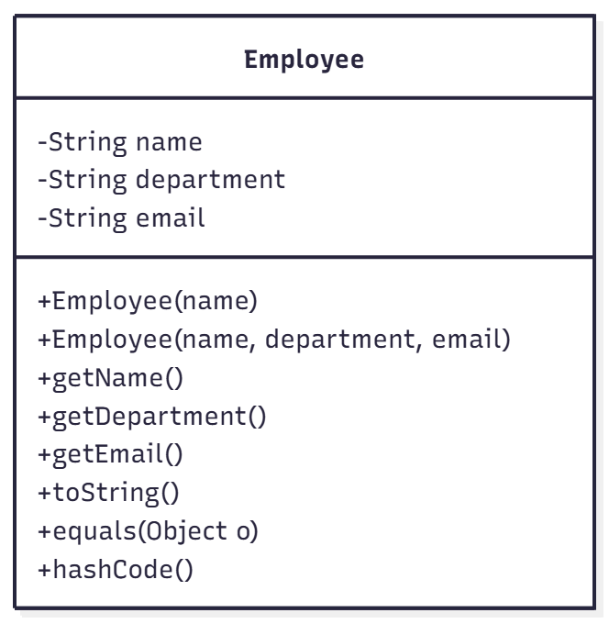
Methods and Time Complexity:
- getName(), getDepartment(), getEmail(): Returns employee info.
Time Complexity: O(1)

- equals(Object o): Compares employess by name.
time Complexity: O(1)

- hashCode(): Supports using employees in hash maps
Time Complexity: O(1)

- toString(): Prints employee name and department
Time Complexity: O(1)

4.4 Room Class
Description: The room class stores information about a meeting room, including its number, capacity, and features like a projector or whiteboard
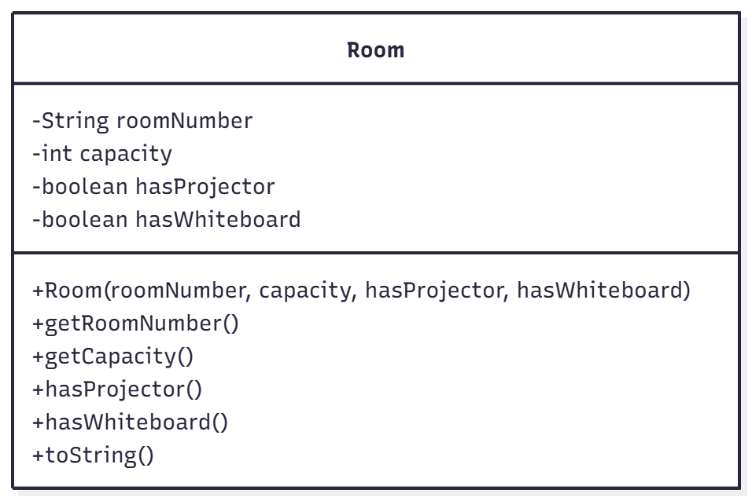
Methods and Time Complexity:
- getRoomNumber(): Returns room number.
Time Complexity: O(1)

- getCapacity(): Returns room capacity.
Time Complexity: O(1)

- hashProjector(): Checks if room has projector.
Time Complexity: O(1)

- hasWhiteboard(): Checks if room has whiteboard.
Time Complexity: O(1)

- toString(): Returns room information as text.
Time Complexity: O(1)

4.5 MeetingNode Class
Description: A MeetingNode is one node in the linked list. It stores one meeting and a link to the next node.
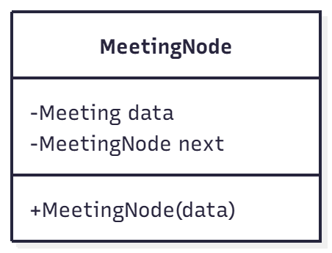
Method and its Time Complexity:
- MeetingNode(data): Creates a new node
Time Complexity: O(1)

4.6 MeetingList Class
Description: A MeetingList is a linked list stores all meetings. It allows adding, removing, and searching meetings.
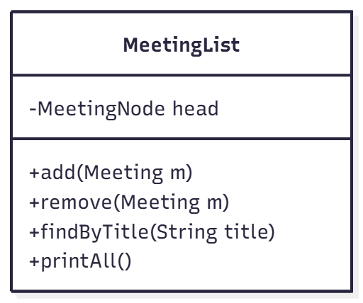
Methods and Time Complexity:
- Add(Meeting m ): adds meeting at the end.
Time Complexity: O(n)

- Remove(Meeting m): removes a meeting by searching for it.
Time Complexity: O(n)

- findByTitle(String title): Finds a meeting by title.
Time Complexity: O(n)

- printAll(): prints all meetings.
Time Complexity: O(n)

4.7 DailySchedule Class
Description: The DailySchedule stores all meetings for a specific day in an Arraylist. It keeps the meetings sorted by time.

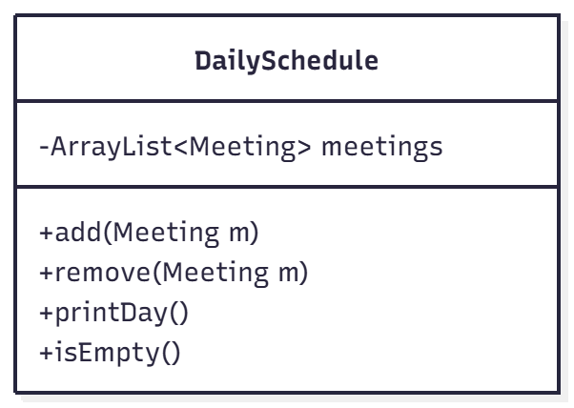
Methods and Time Complexity:
- add(Meeting m): inserts meeting in correct time order.
Time Complexity: O(n log n)

- remove(Meeting m): removes meeting from list.
Time Complexity: O(n)

- printDay(): prints all meetings for that day.
Time Complexity: O(n)

- isEmpty(): checks if there are no meetings.
Time Complexity: O(1)

4.8 MonthlyCalendar Class
Description: The MonthlyCalendar organizes all meetings by date using HashMap. Each date points to a DailySchedule.
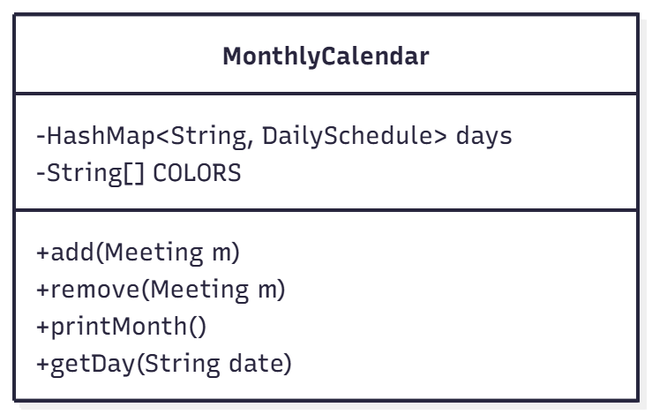
Methods and Time Complexity:
- add(Meeting m): Adds meeting to the correct date.
Time Complexity: O(1)

- remove(Meeting m): Removes meeting from that date.
Time Complexity: O(n)

- printMonth(): Prints every day and its meeting in order.
Time Complexity: O(n)

- getDay(String date): Returns schedule for a date.
Time Complexity: O(1)

4.9 MeetingScheduler Class
Description:
- This is the main manger of the whole system.
- It handles adding, deleting, searching, and organizing meetings.
- It uses several data structures: - Linked list (MeetingList)
- Calendar (MonthlyCalendar)
- HashMaps (for rooms and employees)
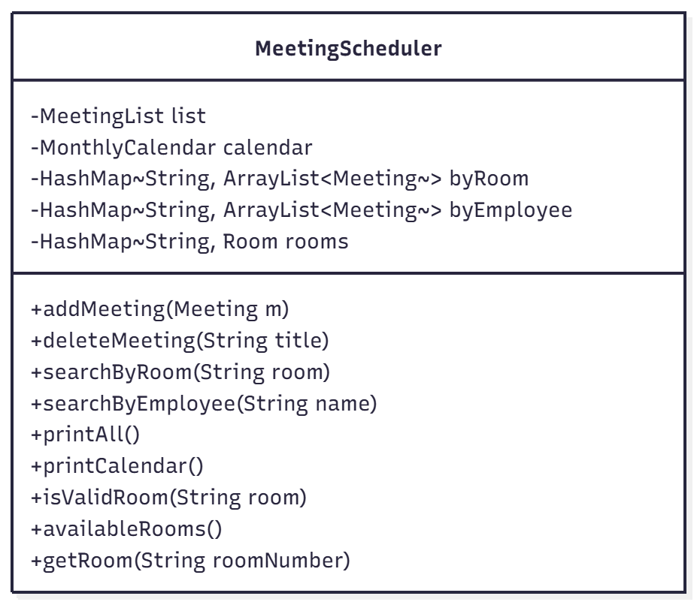
Methods and Time Complexity:
- addMeeting(Meeting m): Checks room, checks conflicts, adds to lists and calendar.
Time Complexity: O(n)

- deleteMeeting(String title): Searches and removes meeting.
Time Complexity: O(n)

- searchByRoom(String room): Uses HashMap to get meetings.
Time Complexity: O(1)

- searchByEmployee(String name): Uses HashMap to get meetings.
Time Complexity: O(1)

- printAll(): prints all meetings in list.
Time Complexity: O(n)

- printCalendar(): prints monthly calendar.
Time Complexity: O(n)

- isValidRoom(String room): checks if room exists.
Time Complexity: O(1)

- availableRooms(): prints all rooms.
Time Complexity: O(n)

- getRoom(String roomNumber): returns room info.
- Time Complexity: O(1)

4.10 Validator Class
Description: The Validator class checks if dates and times entered by the user are correct. It helps prevent invalid inputs.
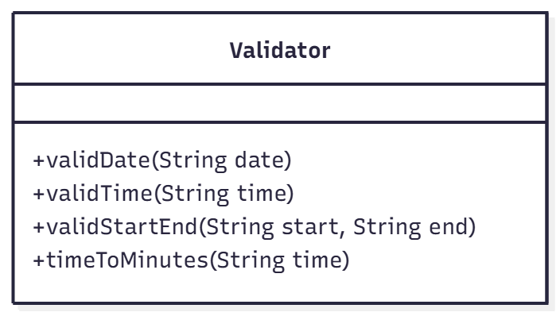
Method and Time Complexity:
- validDate(String date): Checks date format (YYYY-MM-DD).
Time Complexity: O(1)

- validTime(String Time): Checks time format ( HH:MM)
Time Complexity: O(1)

- validStartEnd(String start, String end): Checks if end is after start
Time Complexity: O(1)

- timeToMinutes(String time): converts time to minutes.
Time Complexity: O(1)

5. System Testing
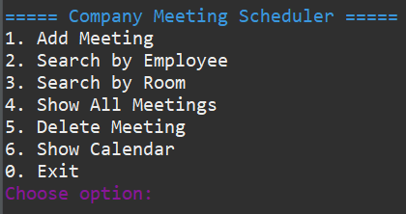
(Program waits for user choice)

5.1 Add Meeting (option 1)
- User will write the Title, Date, Start time, End time, Room, and Employees.

A- Invalid date input
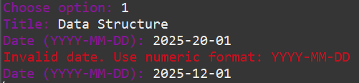

- Date not in YYYY-MM-DD numeric form
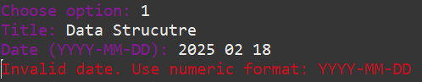
Or invalid day/month
- Program asks foe date again until valid

B- Invalid start/end time
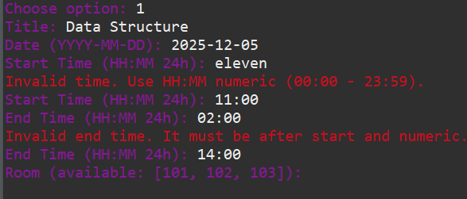

- Time malformed (letters, wrong format,
or out of range).
- Time invalid format or not numeric HH:MM

- End time before or equal to start: end time is
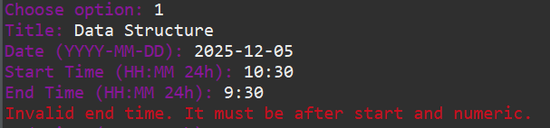
earlier than or equal to start, system does
not accept overnight meetings.

C- Invalid room:
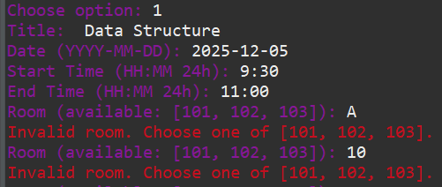
- User types a room not in scheduler rooms

D- Successful add:

- All inputs valid and no conflicts
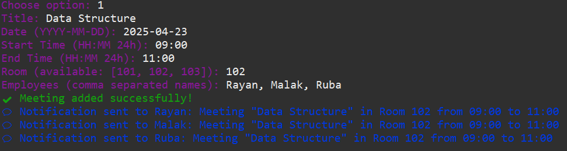

F- Employee Time Conflict:
When you add a new meeting, the program checks every employee in that meeting to make
sure: - They do not already have another meeting
- On the same date

- With Overlapping time

If they do, the system blocks the new meeting and prints a conflict message.

- Meeting 1 Malak, 10:00 – 11:00
- Meeting 2 Malak, 10:30 – 12:00

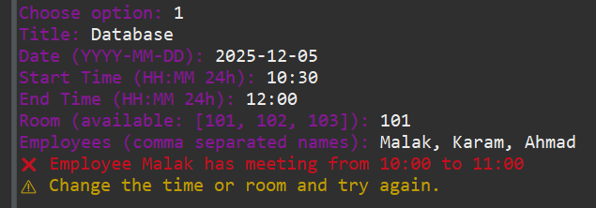

G- Room Conflict:
If a room already has a meeting scheduled at the same time, the system will not allow a new meeting in that room.

- Meeting 1 Room 101, 10:00 – 11:00
- Meeting 2 Room 101, 10:30 – 11:30

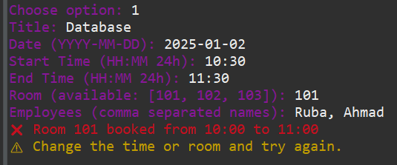

5.2 Search by Employee (option 2)
When a user wants to see the meetings of a specific employee, the system looks up the employee’s name in a hashMap.
If the employee exists in the map, the system prints all the meetings in the list.

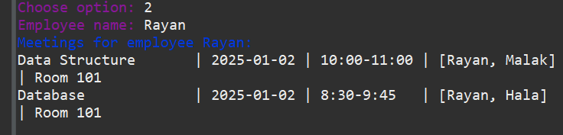

5.3 Search by Room (option 3)
Shows all meetings scheduled in a specific room. Uses a HashMap where the room number is the key and the value is the list of meetings in that room.
If meetings exist, it prints them; it not, it prints “No Meetings.”

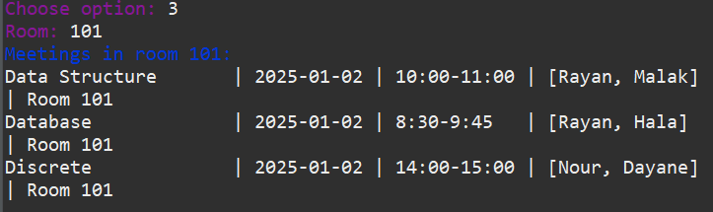

5.4 Show All Meetings (option 4)
Meetings in linked lists. printAll() traverses linked list and prints each node.

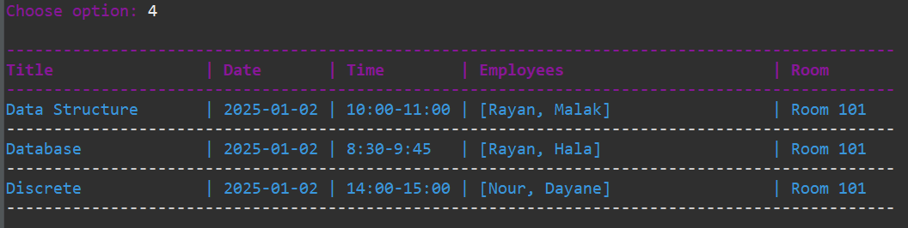

5.5 Delete Meeting (option 5)
- User types the title o the meeting they want to delete
- The program uses MeetingList.findByTitle() to search for a node in the linked List that matches the given title (case-insensitive)
- If a meeting is found, MeetingList.remove() removes the node from the linked list.
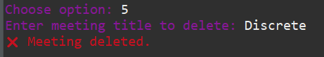

5.6 Show Monthly Calendar (option 5)
The user chooses to view the monthly calendar, which shows all scheduled meetings by date in an organizing way.
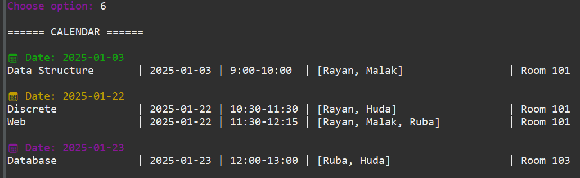

5.7 Exit (option 0)
The program closes the Scanner input
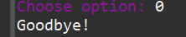

6. Code

public class MeetingNode {
Meeting data;
MeetingNode next;

public MeetingNode(Meeting data) {
this.data = data;
}
}

import java.util.ArrayList;
import java.util.List;
import java.util.stream.Collectors;

public class Meeting {
private final String title;
private final String date;
private final String startTime;
private final String endTime;
private final String room;
private final ArrayList<Employee> employees;

public Meeting(String title, String date, String startTime, String endTime,
ArrayList<Employee> employees, String room) {
this.title = title;
this.date = date;
this.startTime = startTime;
this.endTime = endTime;
this.room = room;
this.employees = employees != null ? employees : new ArrayList<>();
}

public String getTitle() { return title; }
public String getDate() { return date; }
public String getStartTime() { return startTime; }
public String getEndTime() { return endTime; }
public String getRoom() { return room; }
public List<Employee> getEmployees() { return employees; }

@Override
public String toString() {
String emps = employees.stream().map(Employee::getName).collect(Collectors.joining(", "));
return String.format("%-20s | %-10s | %-11s | %-30s | Room %-3s",
title, date, startTime + "-" + endTime, "[" + emps + "]", room);
}
}

// Linked list to store meetings
public class MeetingList {
MeetingNode head;

public void add(Meeting m) {
MeetingNode node = new MeetingNode(m);
if (head == null) {
head = node;
return;
}
MeetingNode cur = head;
while (cur.next != null) cur = cur.next;
cur.next = node;
}

public boolean remove(Meeting m) {
if (head == null) return false;
if (head.data == m) {
head = head.next;
return true;
}
MeetingNode cur = head;
while (cur.next != null && cur.next.data != m) cur = cur.next;
if (cur.next == null) return false;
cur.next = cur.next.next;
return true;
}

// Find first node with title (case-insensitive)
public MeetingNode findByTitle(String title) {
MeetingNode cur = head;
while (cur != null) {
if (cur.data.getTitle().equalsIgnoreCase(title)) return cur;
cur = cur.next;
}
return null;
}

// Print list as table
public void printAll() {
System.out.println("\n\u001B[35m----------------------------------------------------------------------------------------------\u001B[0m");
System.out.printf("\u001B[1m\u001B[35m%-20s | %-10s | %-11s | %-30s | %-6s\n\u001B[0m",
"Title", "Date", "Time", "Employees", "Room");
System.out.println("\u001B[35m----------------------------------------------------------------------------------------------\u001B[0m");

MeetingNode cur = head;
while (cur != null) {
System.out.println("\u001B[36m" + cur.data + "\u001B[0m");
System.out.println("\u001B[37m----------------------------------------------------------------------------------------------\u001B[0m");
cur = cur.next;
}
}
}

public class Employee {
private final String name;
private String department;
private String email;

public Employee(String name) {
this(name, "Unknown", "unknown@example.com");
}

public Employee(String name, String department, String email) {
this.name = name.trim();
this.department = department;
this.email = email;
}

public String getName() { return name; }
public String getDepartment() { return department; }
public String getEmail() { return email; }

@Override
public String toString() {
return name + (department != null && !department.isEmpty() ? " (" + department + ")" : "");
}

@Override
public boolean equals(Object o) {
if (!(o instanceof Employee)) return false;
return this.name.equalsIgnoreCase(((Employee) o).name);
}

@Override
public int hashCode() {
return name.toLowerCase().hashCode();
}
}

public class Room {
private final String roomNumber;
private final int capacity;
private final boolean hasProjector;
private final boolean hasWhiteboard;

public Room(String roomNumber, int capacity, boolean hasProjector, boolean hasWhiteboard) {
this.roomNumber = roomNumber;
this.capacity = capacity;
this.hasProjector = hasProjector;
this.hasWhiteboard = hasWhiteboard;
}

public String getRoomNumber() { return roomNumber; }
public int getCapacity() { return capacity; }
public boolean hasProjector() { return hasProjector; }
public boolean hasWhiteboard() { return hasWhiteboard; }

@Override
public String toString() {
return "Room " + roomNumber + " | Cap: " + capacity +
" | Projector: " + hasProjector + " | Whiteboard: " + hasWhiteboard;
}
}

import java.util.ArrayList;
import java.util.Collections;
import java.util.HashMap;
import java.util.List;

public class MonthlyCalendar {
private final HashMap<String, DailySchedule> days = new HashMap<>();

// ANSI color codes for days
private final String[] COLORS = {
"\u001B[32m", // Green
"\u001B[33m", // Yellow
"\u001B[35m", // Magenta
"\u001B[34m" // Blue
};

public void add(Meeting m) {
days.putIfAbsent(m.getDate(), new DailySchedule());
days.get(m.getDate()).add(m);
}

public void remove(Meeting m) {
DailySchedule ds = days.get(m.getDate());
if (ds != null) {
ds.remove(m);
if (ds.isEmpty()) days.remove(m.getDate());
}
}

// Print dates in chronological order with colors
public void printMonth() {
if (days.isEmpty()) {
System.out.println("No meetings in calendar.");
return;
}

System.out.println("\n====== CALENDAR ======");
List<String> sortedDates = new ArrayList<>(days.keySet());
Collections.sort(sortedDates); // "YYYY-MM-DD" sorts lexicographically

int colorIndex = 0;
for (String date : sortedDates) {
String color = COLORS[colorIndex % COLORS.length];
System.out.println(color + "\n📅 Date: " + date + "\u001B[0m");
days.get(date).printDay();
colorIndex++;
}
}

public DailySchedule getDay(String date) {
return days.get(date);
}
}

public class Validator {

public static boolean validDate(String date) {
if (date == null) return false;
String[] parts = date.split("-");
if (parts.length != 3) return false;
if (!isDigits(parts[0]) || !isDigits(parts[1]) || !isDigits(parts[2])) return false;

try {
int y = Integer.parseInt(parts[0]);
int m = Integer.parseInt(parts[1]);
int d = Integer.parseInt(parts[2]);
if (m < 1 || m > 12) return false;
int md = daysInMonth(y, m);
return d >= 1 && d <= md;
} catch (NumberFormatException ex) {
return false;
}
}

public static boolean validTime(String time) {
if (time == null) return false;
String[] parts = time.split(":");
if (parts.length != 2) return false;
if (!isDigits(parts[0]) || !isDigits(parts[1])) return false;

try {
int h = Integer.parseInt(parts[0]);
int m = Integer.parseInt(parts[1]);
return h >= 0 && h <= 23 && m >= 0 && m <= 59;
} catch (NumberFormatException ex) {
return false;
}
}

public static boolean validStartEnd(String start, String end) {
if (!validTime(start) || !validTime(end)) return false;
return timeToMinutes(start) < timeToMinutes(end);
}

public static int timeToMinutes(String time) {
String[] p = time.split(":");
int h = Integer.parseInt(p[0]);
int m = Integer.parseInt(p[1]);
return h * 60 + m;
}

private static boolean isDigits(String s) {
if (s == null || s.isEmpty()) return false;
for (char c : s.toCharArray()) if (!Character.isDigit(c)) return false;
return true;
}

private static int daysInMonth(int year, int month) {
switch (month) {
case 2:
if ((year % 400 == 0) || (year % 4 == 0 && year % 100 != 0)) return 29;
return 28;
case 4: case 6: case 9: case 11:
return 30;
default:
return 31;
}
}
}

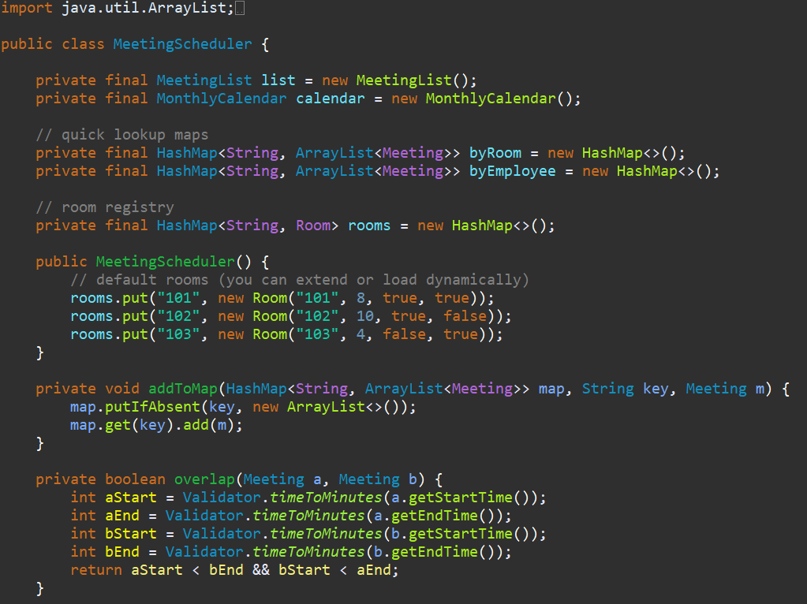
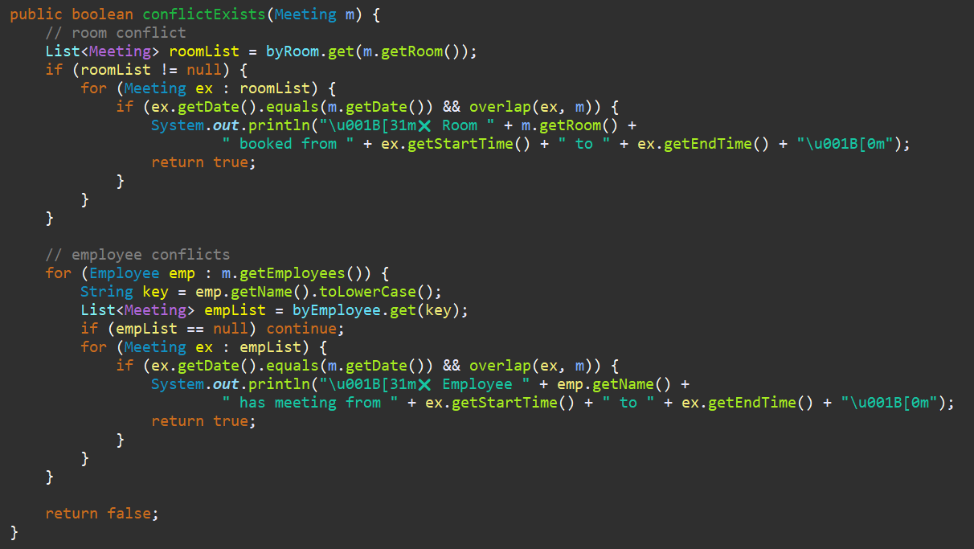
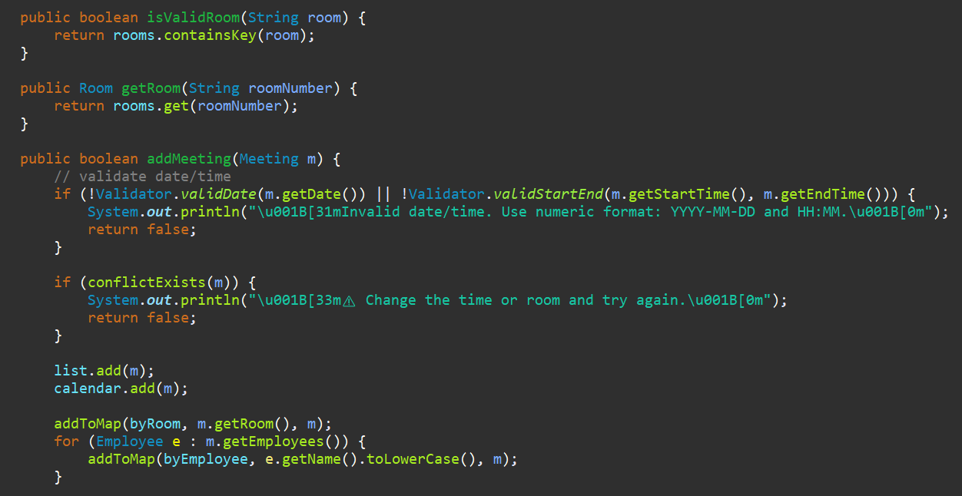
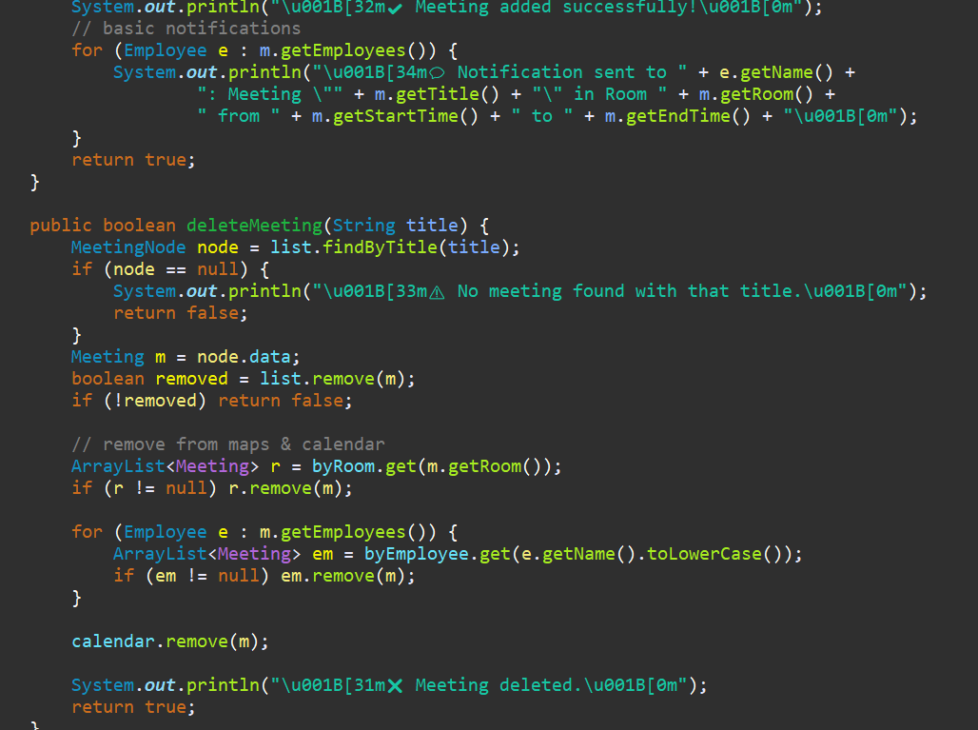
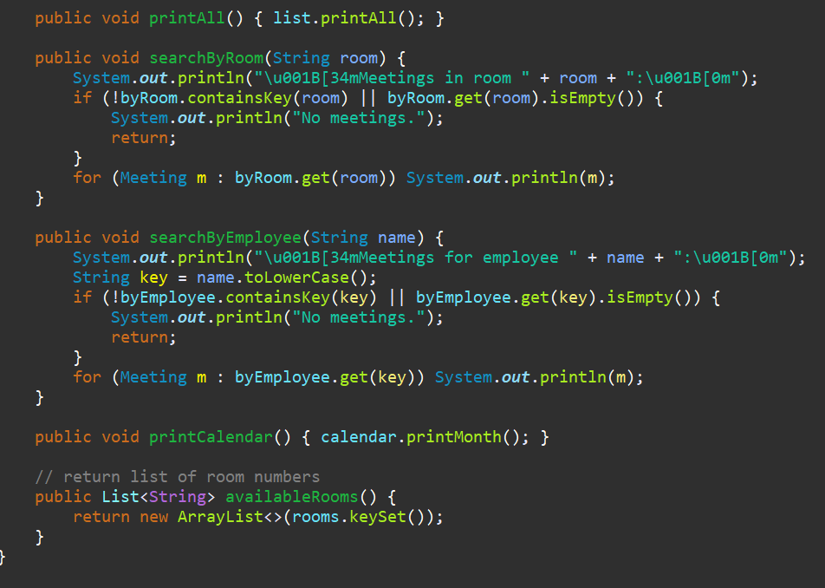

import java.util.ArrayList;
import java.util.List;
import java.util.Scanner;

public class Main {
public static void main(String[] args) {
Scanner input = new Scanner(System.in);
MeetingScheduler scheduler = new MeetingScheduler();

while (true) {
printMenu();
String choiceRaw = input.nextLine().trim();
int choice;
try { choice = Integer.parseInt(choiceRaw); }
catch (NumberFormatException e) {
System.out.println("\u001B[31mPlease enter a number.\u001B[0m");
continue;
}

switch (choice) {
case 1: addMeetingFlow(input, scheduler); break;
case 2:
System.out.print("\u001B[35mEmployee name: \u001B[0m");
scheduler.searchByEmployee(input.nextLine().trim());
break;
case 3:
System.out.print("\u001B[35mRoom: \u001B[0m");
scheduler.searchByRoom(input.nextLine().trim());
break;
case 4: scheduler.printAll(); break;
case 5:
System.out.print("\u001B[35mEnter meeting title to delete: \u001B[0m");
scheduler.deleteMeeting(input.nextLine().trim());
break;
case 6: scheduler.printCalendar(); break;
case 0:
System.out.println("Goodbye!");
input.close();
return;
default:
System.out.println("\u001B[31mInvalid choice.\u001B[0m");
}
}
}

private static void printMenu() {
System.out.println("\n\u001B[36m===== Company Meeting Scheduler =====\u001B[0m");
System.out.println("1. Add Meeting");
System.out.println("2. Search by Employee");
System.out.println("3. Search by Room");
System.out.println("4. Show All Meetings");
System.out.println("5. Delete Meeting");
System.out.println("6. Show Calendar");
System.out.println("0. Exit");
System.out.print("\u001B[35mChoose option: \u001B[0m");
}

private static void addMeetingFlow(Scanner input, MeetingScheduler scheduler) {
System.out.print("\u001B[35mTitle: \u001B[0m");
String title = input.nextLine().trim();

String date;
while (true) {
System.out.print("\u001B[35mDate (YYYY-MM-DD): \u001B[0m");
date = input.nextLine().trim();
if (Validator.validDate(date)) break;
System.out.println("\u001B[31mInvalid date. Use numeric format: YYYY-MM-DD (no letters).\u001B[0m");
}

String start;
while (true) {
System.out.print("\u001B[35mStart Time (HH:MM 24h): \u001B[0m");
start = input.nextLine().trim();
if (Validator.validTime(start)) break;
System.out.println("\u001B[31mInvalid time. Use HH:MM numeric (00:00 - 23:59).\u001B[0m");
}

String end;
while (true) {
System.out.print("\u001B[35mEnd Time (HH:MM 24h): \u001B[0m");
end = input.nextLine().trim();
if (Validator.validTime(end) && Validator.timeToMinutes(end) > Validator.timeToMinutes(start)) break;
System.out.println("\u001B[31mInvalid end time. It must be after start and numeric.\u001B[0m");
}

String room;
List<String> rooms = scheduler.availableRooms();
while (true) {
System.out.print("\u001B[35mRoom (available: " + rooms + "): \u001B[0m");
room = input.nextLine().trim();
if (scheduler.isValidRoom(room)) break;
System.out.println("\u001B[31mInvalid room. Choose one of " + rooms + ".\u001B[0m");
}

System.out.print("\u001B[35mEmployees (comma separated names): \u001B[0m");
String employeeInput = input.nextLine().trim();
ArrayList<Employee> employees = new ArrayList<>();
for (String part : employeeInput.split(",")) {
String n = part.trim();
if (!n.isEmpty()) employees.add(new Employee(n));
}

Meeting meeting = new Meeting(title, date, start, end, employees, room);
scheduler.addMeeting(meeting);
}
}

7.Coclusion
The Meeting Scheduler System was created to make planning and managing meetings easier and more organized. It helps users add, view, and delete meetings without confusion. The system checks for conflicts so that no employee or room is double-booked. It also shows a monthly calendar that makes it simple to see al meetings in one place.
In this project, we used several data structures to make the system work smoothy. We used Linked Lists to store all meetings in order, HashMaps to quickly find meetings by room and by employee, and Arrays to store fixed information like room numbers. These data structures help the system run fast and stay well-organized.
Overall, the project gives a complete scheduling solution. It allows users to enter meeting details, search for meetings, delete them, and view them in a calendar format. It is easy to use, keeps everything clear, and reduces mistakes in planning. The system shows how data structures and simple design can create an organized and useful tool for everyday work.

